Yaqin VK2100 maintenance
Be very careful with the leads; if one slips and shorts out something that should not be shorted, you blow the amp. Have a very calm hand doing this.
Performing this sort of thing in this amp in particular is a little more dangerous than usual, as there are HIGH VOLTAGES present not far away from where you will be doing this. The amp power rails themselves are only a couple dozen volts, but the power supply for the tubes is in the hundreds of volts. BEWARE!

Bias
The procedure is somewhat time/temperature dependent. You want to do it when the amp is fully warmed up. Have it idle (that is on, but not really doing anything) for about 1/2 hour with the cover on, but screws removed.

Measure here:
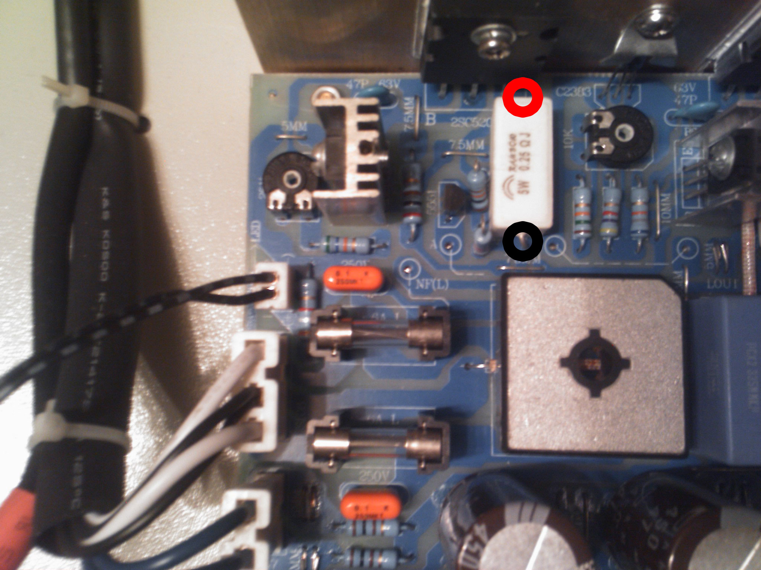
And adjust with the potentiometer to the right till you measure ±15~±25mV, ±15mV will make it run cooler, and ±25mV will make it sound more class A. It shouldn't matter, but just to be save: If your first measurements are positive, keep it positive, if they're negative, keep them negative. More to the right of the board you will find the same kind of layout with again a potentiometer (the most to the right), do the same thing there and make sure your measurements are within 1~2mV of each other.

After you adjust and balance, replace the cover without replacing the screws and start playing some music. Make sure it sounds okay, and let it go at a medium-low volume for about half an hour. After that, stop the music and check the bias again. It should not have drifted or only drifted a little. Re-calibrate if needed, otherwise replace the cover and screws and your set.
DC offset
Checking for offset, just connect your MM to the speaker outputs, preferably with an 8Ω/ >20-watt resistor connected up across the + and -, and adjust the DC offset pot inside (the potentiometers you didn’t use while adjusting bias) to get as close to 0mV as possible, though anything between -50mV and +50mV is acceptable. You will become frustrated, though- as soon as you put the cover on, the DC will drift somewhat, and after it warms up inside, it will drift a lot. So, you want to compensate for this when you have the cover off. If the DC drifts +20mV in one channel after the cover is replaced, and it has warmed up, adjust the DC offset for xmV - 20mV when the cover is off: i.e. the best you can get is ±15mV with the cover off, but it jumps to ±35mV when the cover is replaced, adjust the bias to 15mV±20mV in the appropriate direction so that the offset "drifts" towards 0.

